We proudly serve K Bay Coffee out of Homer, Alaska. All beans are organically grown and roasted to perfection. Bring your own cup and receive $.25 off your drink.
Espresso Drinks 12oz 16oz 20oz
Americano 2.25 3.00 4.00
Cappuccino 4.00 5.00 6.00
Latte 4.00 5.00 6.00
Mocha 4.50 5.25 6.25
Breve 4.50 5.25 6.25
Mocha Breve 4.75 5.75 6.50
For The Serious Coffee Lover
Doppio 2.25 …………………
Machiatto 3.00 …………………
Con Panna 3.00 …………………
Cubano 2.25 …………………
Keeping It Hot 12oz 16oz 20oz
Drip Coffee 2.50 3.00 4.00
Shot in the Dark 3.50 4.50 5.25
Steamer 3.00 3.75 4.75
Hot Cocoa 3.00 3.75 4.75
Chillers 16oz 24oz
Smoothie 5.25 7.25
Frappe 5.25 7.25
Iced Americano 2.50 4.50
Iced Latte 4.50 6.50
Iced Mocha 5.00 6.75
Italian Soda 4.25 5.75
Red Bull/LOTUS Soda 4.75 7.75
Iced Tea 3.25 4.25
Hot Teas 12oz 16oz 20oz
Alaska Chai 4.00 5.00 6.00
Loose Leaf Tea 3.00 3.25 3.50

Home Baked Goodies
Cookies $2.75
Fresh Muffins $3.50
Homemade Breads $3.50

*Prices and menu options are subject to change

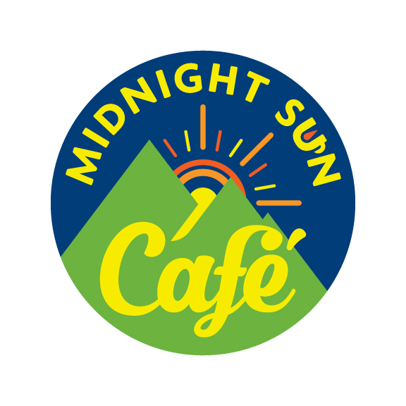

245 W 5th Ave. Suite 106, Anchorage, AK 99501
(On the corner of 5th and C St, below 5th Ave. Parking Center)
www.midnightsuncafeak.com
Phone: 743-0572
Free WiFi
Panini and Deli Sandwiches
Vegetarian Options
Homemade Dressings & Sauces
Soups Made From Scratch
Light Breakfast
Homemade Baked Goods
Catering
We Recycle

Monday-Friday 7am-4pm
Saturday-Sunday 8am-4pm

Please alert staff to any food allergies. Some items may contain nuts, wheat, milk, eggs, and fish. Consuming raw or undercooked eggs may increase your risk of foodborne illness.
Breakfast
Egg & Cheese Breakfast Sammy $6.00
Served on a Croissant or English Muffin
ADD Sausage $1.00 Avocado $1.50
Ham $1.00 Extra Meat per oz. $1.00
Turkey $1.00 Extra Bacon $1.50
Bacon $1.00 On a Bagel $.75
Veggie
Fried Egg, Tomato, Spinach, Swiss $7.50
The Flying Pig $9.50
Ham, Sausage, Bacon, Fried Egg, American Cheese
Angry Flying Pig $9.75
Ham, Sausage, Bacon, Fried Egg, Pepper Jack Cheese, Jalapenos
Fly’n Pig in the Garden $10.00
Ham, Sausage, Bacon, Fried Egg, Swiss Cheese, Tomato, Spinach
The Cory $7.50
2 Fried Eggs, American, Pepper Jack Cheese
Fruit & Yogurt Parfait w/Granola $5.50

Warm & Toasty Homemade Soup C $5.00 B $7.00
Deli Sandwiches Half Whole
Classic Ham & Cheddar $7.00 $11.50
Black Forest Ham, Cheddar Cheese, Lettuce, Tomatoes, Red Onions, Dijon Mustard
Turkey Swiss & Cranberry $7.50 $11.50
Turkey Breast, Swiss Cheese, Lettuce, Red Onions, Cranberry, and Cream Cheese
Turkey Havarti Croissant $12.00
Turkey Breast, Havarti Cheese, Lettuce, Tomato, Red Onions, Zippy Sauce
Roast Beef & Zippy $8.00 $12.00
Roast Beef, Pepper Jack Cheese, Lettuce, Roasted Red Peppers, Zippy Sauce
Panini Whole
Ham & Brie $12.50
Black Forest Ham, Brie, Tomatoes, Spinach Leaves, Garlic Aioli, Basil
Turkey & Pepper Jack $12.50
Turkey Breast, Pepper Jack, Roasted Red Peppers, Spinach Leaves, Mayo
Turkey Bacon Ranch $12.25
Turkey Breast, Bacon, Ranch Dressing, Red Onion, Tomatoes, Lettuce
Roast Beef & Sun-dried Tomato $12.50
Roast Beef, Cheddar Cheese, Red Onions, Spinach Leaves, Sun-Dried Tomato Spread
Cuban $12.50
Salami, Ham, Swiss Cheese, Lettuce, Tomato, Pickles, Dijon Mustard
Zeus $12.50
Salami, Artichoke Hearts, Roasted Red Peppers, Kalamata Olives, Tomatoes, Red Onions, Spinach Leaves, Mozzarella, Parmesan Cheese, Oregano, Basil
Open Faced/Toasted Half Whole
BLT $6.50 $11.00
Bacon, Lettuce, Tomato, Mayo
Tuna Melt $7.00 $11.00
Tuna Salad, Cheddar Cheese, Red Onions, Basil
Ham Melt $7.00 $11.00
Black Forest Ham, Swiss Cheese, Tomatoes, Mayo, Basil
Turkey & Avocado Melt $8.50 $12.75
Turkey Breast, Swiss Cheese, Avocado, Roasted Red Peppers, Red Onion, Tomato, Caesar Dressing
For The Kiddos-Served with Goldfish Crackers
Peanut Butter & Jelly Sandwich $4.75 $6.75
Kids Grilled Cheese $5.25
Vegetarian Half Whole
Veggie $8.00 $11.00
Tomatoes, Spinach Leaves, Cucumbers, Red Onions, Shredded Carrot, Dijon Mustard
Brie Panino ………. $12.50
Brie, Tomatoes, Spinach Leaves, Garlic Aioli, Basil
Avocado Ranch Melt ………….$11.75
Avocado, Swiss Cheese, Roasted Red Peppers, Onion, Tomato, Ranch Dressing
Grilled Cheese ……….. $9.00
Your Choice Of Cheddar, Swiss, Or Pepper Jack
Toasted Caprese ……….. $12.75
Fresh Mozzarella, Tomatoes, Fresh Basil, Olive Oil
Italian Vegetable Goddess ……….. $12.75
Artichoke Hearts, Roasted Red Peppers, Kalamata Olives, Tomatoes, Red Onions, Spinach Leaves, Mozzarella, Parmesan Cheese, Oregano, Basil
Salad Half Whole
Club Salad $8.00 11.00
Romaine Lettuce, Turkey, Ham, Crispy Bacon, Cheddar Cheese, Cucumber, Tomato, Homemade Garlic Croutons, Ranch Dressing
Midnight Sun Salad $8.00 $11.00
Caramelized Walnuts, Red Grapes, Apples, Blue Cheese Crumbles, Spinach/Romaine Mix, Housemade Berry Vinaigrette
Chicken Caesar Salad $8.00 $11.00
Romaine Lettuce, Homemade Garlic Croutons, Parmesan Cheese, Housemade Caesar Dressing
Without Chicken $6.25 $9.75
Greek Salad $8.00 $11.00
Romaine Lettuce, Genoa Salami, Kalamata Olives, Pepperoncini, Cucumber, Tomatoes, Feta Cheese, Garlic Croutons, Housemade Balsamic Vinaigrette
Mediterranean Pasta Salad $5.00 $7.00
Penne Pasta, Artichoke Hearts, Sun-Dried Tomatoes, Black Olives, Feta & Parmesan Cheese, Housemade Creamy Italian Dressing
Chef Specials Whole $12.75
Spicy Italian Panini- Pepperoni, Salami, Ham, Roasted Red Peppers, Pepperoncini, Parmesan Cheese, Balsamic Vinaigrette
Hot Jack Melt- Pepperoni, Turkey Breast, Jalapenos, Pepper Jack Cheese, Garlic Aioli
Johnny Boy’s Melt- Roast Beef, Havarti Cheese, Red Onion, Jalapenos, Housemade Blue Cheese Dressing
AC Melt- Turkey Breast, Bacon, Cream Cheese, Cheddar Cheese, Red Onion, Jalapenos

